Emperor Penguins
Emperor Penguins are birds but they cannot fly.
Emperor penguin chicks are black, white and grey with a small amount of feathers. The adult penguins are black, white and yellow. The adult penguins are black white and yellow. The black and white looks like a suit and the yellow is around their neck with a beak and webbed feet. Their webbed feet have very big claws and some penguins even have red beaks for feet. They are about 1 meter tall in height and around 80 to 100 pounds in weight.They are the tallest penguins in the world.
Emperor penguins live in Antarctica , the South Pole. In the winter time it gets to about 70 degrees below zero and in the summer 20 degrees below zero!
An Emperor Penguin lays 1 egg a year. The male and female stay together forever. When the egg is hatched the male stays with the egg for eight weeks while the mother goes and fishes for her baby. When Emperor Penguins leave their babies like most animals, the chick stays with them in a big group with other chicks.
When the chicks parents go fishing they leave their chicks in a kindergarten. Sometimes seven adult penguins look after hundreds of chicks. When danger is around the seven adult penguins form a protective ring around the chicks!
This is what the big group of penguins looks like when the females are all gone to fish.
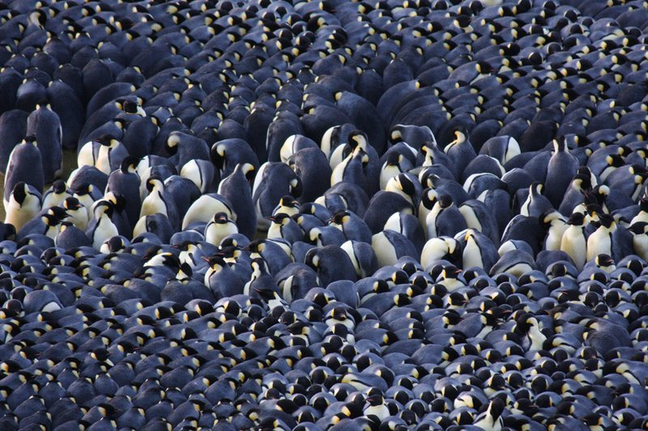
By Saoirse Bergin

