- Oiche Gaelach 
Le ceol, damhsa agus filíocht.

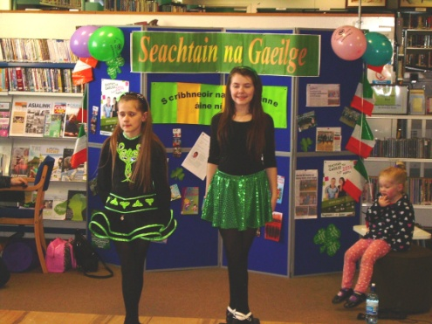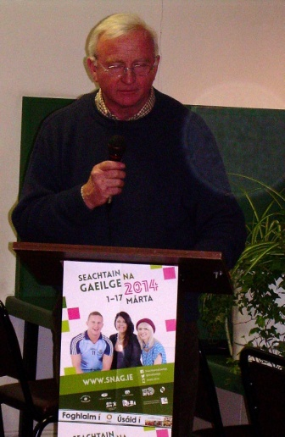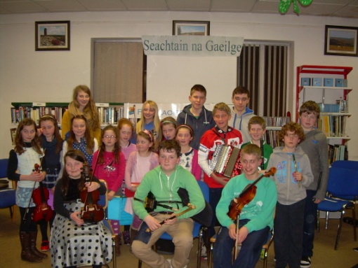

Tar go dtí an Leabharlann chun Seachtain na Gaeilige a cheiliúradh!

Portlaoise Library
Wednesday 4th March
5pm-7pm
Light refreshments will be served.

